

**WHAT’S ON AT THE HUB, STALBRIDGE!**



**CHRISTMAS DAY AT THE HUB: Get together for tea, coffee and Christmas treats from 10am to 12 noon. Open for all.**



COMMUNITY INFORMATION OFFICE: **The team of volunteers provide information on tourism, travel and assistance on local matters. The Office opening hours are Friday 2 - 4.00pm, Saturday , Monday & Wednesday 9.30am to 12 noon.**



**TEA & CHAT : On the first Friday of each month. Hosted by the Community Information office, pop in for a cuppa and a chat open to all.**



**SNOW DROP REMEMBRANCE:** **Weldmar Hospice care hold annual remembrance. services in conjunction with this snowdrops may be planted in memory of your loved ones, and their name included in the Snowdrop Memorial book. The Snowdrop Memorial book is kept at The Hub along with the application forms.**

**PENSION WISE: Appointments are available at The Hub. - Free and impartial government service. Book an appointment to get guidance about your pension options and what you can do next..** **Phone 0800 138 3944 to book a free appointment.**



**STALBRIDGE ARCHIVE GROUP:**

**Meet at the hub every Wednesday morning from 10am.**

**A small group of enthusiastic people have come together to form the Stalbridge Archive Group, whose aim is to preserve photographs, historical documents and artefacts relating to Stalbridge and its people. The Town Council very kindly let the group have some space in the Hub which means that the collection can be stored in a safe and secure environment.**

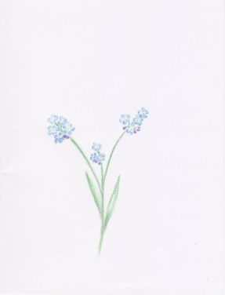**MINDFUL CAFÉ: Mindful Café at the Hub on the 1st Monday of each month.**

**Mindful is a small local charity supporting local projects for people aged 65 and over who have memory loss or dementia and those who care for them. This is a free informal, relaxed & friendly event where people can meet others facing challenges associated with dementia. Contact: Chair & Membership Secretary; 01747 852153 email** [**snutbeem@gmail.com**](mailto:snutbeem@gmail.com)**) Secretary; c/o 01747 851521**

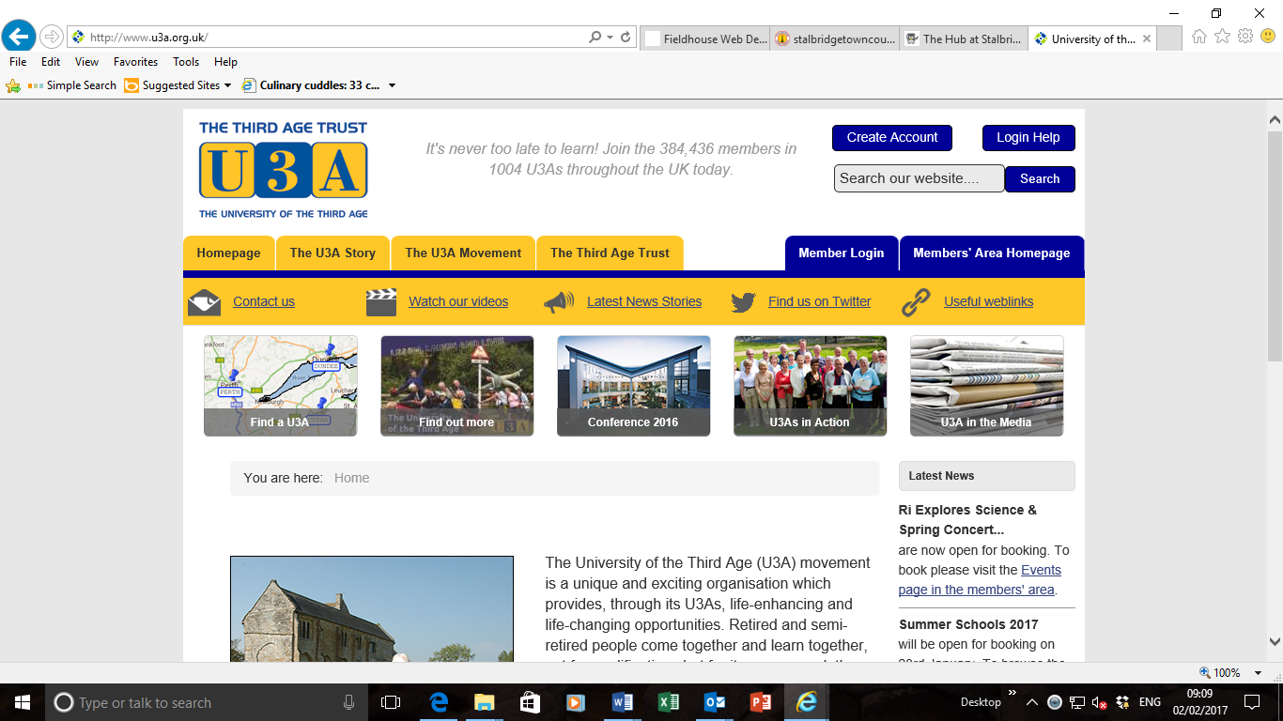

**U3A: An opportunity for retired and semi-retired to people come together and learn together, not for qualifications but for its own reward: the sheer joy of discovery!**

**The Hub hosts sessions for a creative writing Group call Vale Writers on the last Tuesday of each month 2.30-4.30pm. Please contact the Hub for details.**

**The Hub hosts a meditation & relaxation group on the second Tuesday of each month 2.30-4pm**

**DROP IN SESSION: On Tuesday mornings from 10am to 12 noon. Age Concern provide a wide range of services to help people in later life throughout the UK including home help, foot care, transport, handy person services , exercise classes, shipping and social activities. Come and meet your local contact.**

**LOCAL CITIZENS ADVICE BUREAU: Appointments with CAB advisors are available at The Hub. Call the CAB on 03442 451291 and ask to make your appointment in Stalbridge.**

[](https://pixabay.com/en/choir-sing-alto-cappella-praise-306900/)**STALBRIDGE SINGERS:**

**Meet every Thursday night at 7.30pm. Cost £5.00 per session. Come and join in, no audition or requirement to read music.**

**YOGA WITH ALISON :**

**Meet on Thursday mornings 10.30-12 noon. For more information tel: 01963 362669**

**THE COMMUNITY MANAGED LIBRARY: Membership of the library is FREE. Here you can borrow up to 12 books at a time absolutely free! No need ever again to buy a book!**

|  |  |
| --- | --- |
|  | **Opening Times**  **Mon: 2.00 to 5.00pm Tues: 10.00am to 12.30pm & 2.00 to 5.00pm**  **Wed: 12.00 noon to 2.30 pm Thurs: 3.00 to 6.00pm**  **Frid: 2.00 to 5.00pm Sat: 9.30 to 12.30am** |

**You can also borrow books on line to be delivered here for you to collect. If you don't have a computer at home, there are two PCs for the benefit of library users. Contact your own local library. Tel: 01963 362142. Take a look at the new web site http://www.stalbridgelibrary.org**