

**WHAT’S ON AT THE HUB, STALBRIDGE!**

**BLACKMORE VLAE FAMILY HISTORY SOCIETY:**

**Talk ‘The Consequences Of The Conquest ‘ At the Hub Wednesday 13th November for 2pm everyone welcome.**

**STALBRIDGE HISTORY SOCIETY:**

**Stalbridge has a rich history, its famous former residents including Robert Boyle, whose experiments in Stalbridge Park in the 17th century resulted in the compression of air, which gave us our pneumatic tyres, and James Thornhill, painter of the dome of St Paul’s. The Society has regular committee meetings at The Hub and talks out local history topics. Contact Jude Watts 364394 stabridgehistory@gmail.com**

**CUPPA CLUB AT THE HUB :**

**Every Friday 2-4pm. So if you fancy a cuppa and chat at the Hub, in a friendly atmosphere then pop down every Friday from 2pm to 4pm and join in the fun!**

**PENSION WISE:**

**Appointments are available at The Hub. - Free and impartial government service. Book an appointment to get guidance about your pension options and what you can do next.** **Phone 0800 138 3944 to book a free appointment.**

**WHITE HART LINK:**

**The White Hart Link is a 50 mile / 80 km walking route which has been devised as a circular link taking in the five market towns of North Dorset and the villages between. Using existing public rights of way and quiet lanes, it passes through some of the iconic countryside of the Blackmore Vale. Members of the White hart link team meet at The Hub. They can be contacted via their web site**

**https://www.whitehartlink.uk/.**

**BLACKMORE VALE LIONS:**

**Meet at The Hub once a month. The club is an autonomous part of lions clubs international which has 1.3 million members worldwide. assistance is given locally in North Dorset and South Somerset to individuals, groups and other charities by way of equipment purchases, grants etc. support is also given to national and international causes recognised by lions clubs international, particularly health, sight and youth issues.**

**______________________________________________________________________**

**CITIZENS ADVICE BUREAU:**

**Appointments with CAB advisors are available at The Hub. Call the CAB on 03442 451291 and ask to make your appointment in Stalbridge.**

**STALBRIDGE ARCHIVE GROUP:**

**Meet at The Hub every Wednesday morning from 10am. A small group of enthusiastic people have come together to form the Stalbridge Archive Group, whose aim is to preserve photographs, historical documents and artefacts relating to Stalbridge and its people. The Town Council very kindly let the group have some space in the Hub which means that the collection can be stored in a safe and secure environment. They welcome visitors at the sessions. The Archive Society now have a new web site https://www.stalbridgearchive.co.uk/**

**MINDFUL CAFÉ:**

**Mindful Café at The Hub on the 1st Monday of each month.**

**Mindful is a small local charity supporting local projects for people aged 65 and over who have memory loss or dementia and those who care for them. This is a free informal, relaxed & friendly event where people can meet others facing challenges associated with dementia. Contact them** [**enquiries.mindful@gmail.com**](mailto:enquiries.mindful@gmail.com)

**01747 852153 (Sally Nutbeam) or 07971 338339 (Barbara Turnbull)**

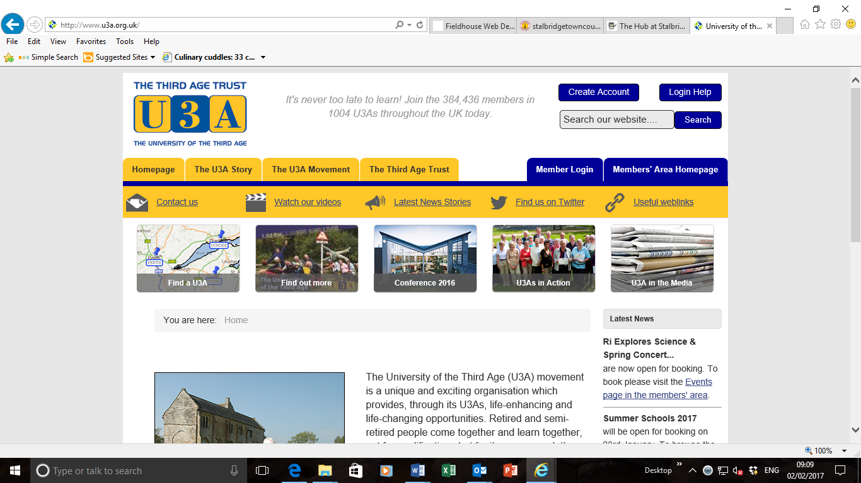

**U3A:**

**An opportunity for retired and semi-retired to people come together and learn together, not for qualifications but for its own reward: the sheer joy of discovery! The Hub hosts sessions of meditation & relaxation group on the second Tuesday of each month 2.30-4pm**

[](https://pixabay.com/en/choir-sing-alto-cappella-praise-306900/)**STALBRIDGE SINGERS:**

**Meet every Thursday night at 7.30pm. Cost £5.00 per session. Come and join in, no audition or requirement to read music.**

**THE COMMUNITY MANAGED LIBRARY: Membership of the library is FREE. Here you can borrow up to 12 books at a time absolutely free! No need ever again to buy a book!**

|  |  |
| --- | --- |
|  | **Opening Times**  **Mon: 2.00 - 5.00pm Tues: 10.00am - 12.30pm & 2.00 - 5.00pm**  **Wed: 12.00 noon - 2.30 pm Thurs: 3.00 - 6.00pm**  **Frid: 2.00 - 5.00pm Sat: 9.30 - 12.30am** |

**You can also borrow books on line to be delivered for you to collect. If you don't have a computer at home, there are two PCs for the benefit of library users. Contact your own local library. Tel: 01963 362142. Library web site http://www.stalbridgelibrary.org**